|  |
| --- |
| **Artificial Intelligence (CS/DS 2002)** |
| Date: 2024 |
| **Course Instructors** |
| Dr. Asma Ahmad |
| Dr. Hajra Waheed |
| Dr. Mirza Mubasher Baig |
| Dr. Sadaf Jabeen |
| Ms. Bushra Rashid |
| Ms. Maham Naeem |
| Ms. Saba Tariq |
| Mr. Saif Ul Islam |

|  |
| --- |
| **FINAL** |
| **Total Time: 3 Hours** |
| **Total Marks: 85** |
| **Total Questions**: 06 |
|  |
| **Semester:** SP-2024 |
| **Campus:** Lahore |

|  |
| --- |
| ____________________________ _________________ _____________________  Student Name Roll No Section Signature |

**ATTEMPT ALL QUESTIONS ON THE ANSWER SHEET**

**Question No 1. [Short Questions] [10 x 3 Points]**

1. It is a well-known fact that a local search algorithm can converge to a local optima. Assume, you have a black-box implementation of a local search algorithm but you want to minimize the probability of finding a locally optimal solution. How can use the black-box implementation (i.e. the implementation you cannot change) to find a better (or perhaps the best) solution by repeatedly using it.

**Multiple Restarts:** Run the algorithm multiple times with different random starting points.

1. Given two arbitrary admissible heuristics, *h1* and *h2*, which composite heuristics are also admissible? Justify.

|  |  |  |  |
| --- | --- | --- | --- |
| 1. Max (*h1*, *h2*) | 1. (*h1* + *h2*)/2 | 1. *Min* (*h1*, *h2*)? | 1. h1*h2 |

Since both h1 and h2 are admissible, the maximum value will also be less than or equal to the actual cost Therefore, **Max(h1, h2)** is also admissible.

The average will also be less than or equal to the actual cost. Therefore, **(h1 + h2) / 2** is also admissible.

1. In an A* implementation, you have a choice of using one of the heuristics given in the previous part. Which one of the heuristics will you use? Justify your choice

**For the next three questions consider the following short game tree being used by minimax to decide a move**.



1. Which terminal nodes will never be explored as a results of pruning if the minimax explores the nodes from left to right i.e. node A is explored first.
2. Now assume that you are allowed to change value of one of the leaf node. Suggest a new value of one of the selected node such that no pruning takes place if the tree is processed from left to right
3. Argue that the following statement is true for local search.

***Hill climbing with random restarts is guaranteed to find the global optimum if it runs long enough on a finite state space.***

1. What would go wrong during gradient based learning if all weights of a multi-layer neural network are initialized to 0 (ZERO)? Think about backpropagation step to answer this question.

All neurons in a layer compute identically due to identical weights, hindering them from learning diverse features. Small initial gradients during backpropagation can vanish or become insignificant in deeper layers, preventing effective weight updates

1. What would be the size of output feature-map if a 7x7 filter is convolved with a 56x56 image with a stride of 2 followed by a 2x2 max pooling with a stride of 2?

Output feature-map: 25x25

Max pooling: 12

1. Calculate the size (i.e. number of learnable weights) of a feed-forward neural network that has a 28x28 image as input and has 20 neurons in a single hidden layer and 10 neurons in the output layer.

Hidden layer: 28x28x20+10 = 15700

Output layer: 20x10+10 = 210

Total weights = 15910

1. Repeat the previous part for the same 28x28 input image and for a CNN with a convolution layer consisting of 10 filters of size 3x3 applied with a stride of 2 followed by a 2x2 max pooling layer and a fully connected layer consisting of 20 neurons in a single hidden layer and 10 neurons in the output layer. Assume that the convolution is applied with zero padding enabled.

Convolutional Layer weights= 3x3x10+10 = 100

Convolution output = 14x14

Max Pool output = 7x7

Hidden layer weights = 7x7x20+20 = 1000

Output layer weights = 20x10+10 = 210

Total = 100+1000+210 = 1310

**Question No 2 [Learning a NN Using Back Propagation] (Marks: 15)**

Calculate new weights and bias values by using Back propagation Algorithm. Multi-layer feed-forward neural network is given below. The input and target values for this problem are x1=10, x2=40, x3=50 and target at O1=0 and O2=1. Initialization of weights is already given below. Calculate the updated weights using Back Propagation Algorithm where network uses ReLU as activation function in the hidden layer and sigmoid activation at the output layer. Assume the learning rate of.

The marks will be awarded for the following

i) Correct forward pass **(5 Points)** ii) Correct Gradient terms calculated at the output layer **(2 Points)**  
iii) Correct propagation of gradients from output to hidden layers **(4 Points)** and iv) correctly updating the weights **(4 Points)**

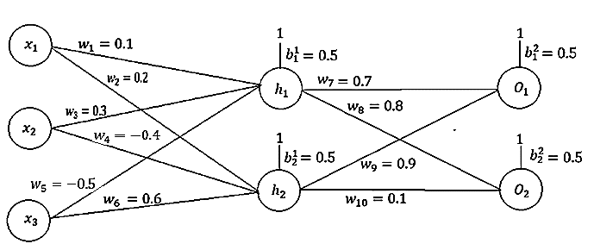

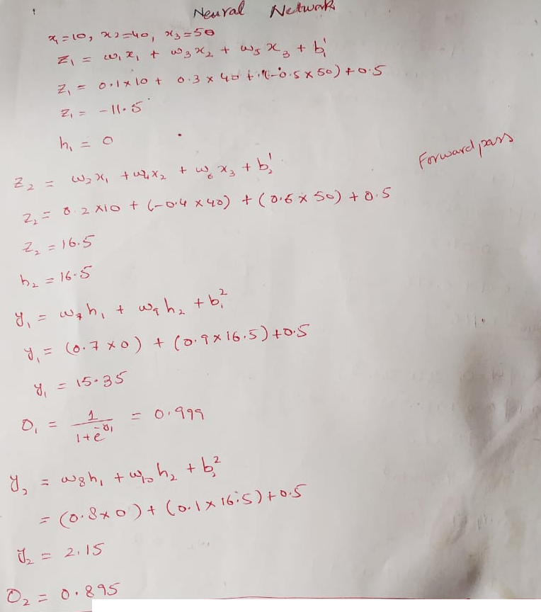

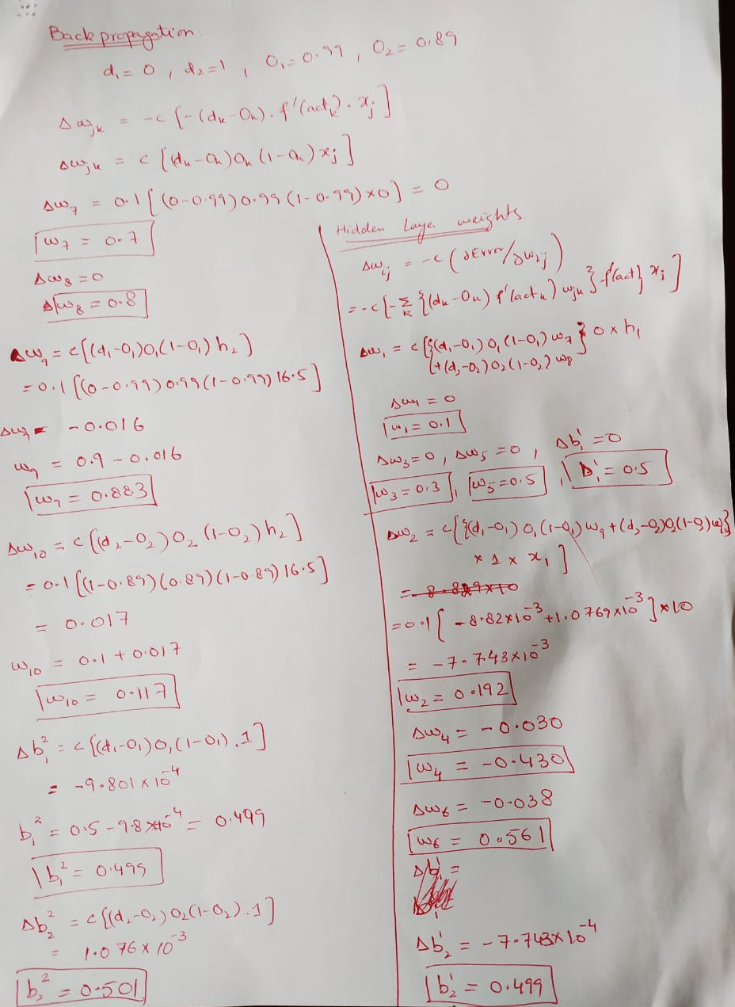

**Question No 3 [CNN] [5 + 2 + 3 Points]**

1. Using the given 6x6 input image and a 3x3 filter with a stride of 1 and a bias of 1, compute the output feature map obtained after applying ReLU activation. Assume that zero-padding is not applied during the convolution operation.

|  |  |
| --- | --- |
| **Image** | **Filter** |
|  |  |

|  |  |  |  |
| --- | --- | --- | --- |
| -4 | -3 | 1 | 9 |
| -9 | -1 | 3 | 4 |
| 1 | -1 | -3 | -6 |
| -2 | -1 | -2 | -15 |

After RELU

|  |  |  |  |
| --- | --- | --- | --- |
| 0 | 0 | 1 | 9 |
| 0 | 0 | 3 | 4 |
| 1 | 0 | 0 | 0 |
| 0 | 0 | 0 | 0 |

1. Apply a 2x2 max pooling filter on the resultant feature map with stride=2 and show the output matrix.

0 9

1 0

1. Flatten the resultant output from the MaxPool and pass it to a output layer with a single neuron. Take any weights of your choice for the output neuron and compute the final output assuming that the sigmoid activation is used at the output layer. Don’t forget to include the bias term at the output layer.

**Question No 4 [Measuring Performance of Learning Algorithms] [4 + 6 Points]**

Imagine you have a dataset containing samples of flowers, where each flower can be classified into one of three categories: roses, daisies, or tulips. You've trained a neural network on this dataset and evaluated it on test data. After evaluation, you've obtained the following results:

1. Out of the 50 roses in the test set, the model correctly predicted 40 as roses, but mistakenly classified 5 as daisies and 5 as tulips.
2. Out of the 50 daisies in the test set, the model correctly predicted 45 as daisies, but mistakenly classified 3 as roses and 2 as tulips.
3. Out of the 50 tulips in the test set, the model correctly predicted 48 as tulips, but mistakenly classified 1 as roses and 1 as daisies.
4. Show a confusion matrix for this model using the information of performance given above
5. Using the confusion matrix created in previous part compute accuracy, average precision, average recall

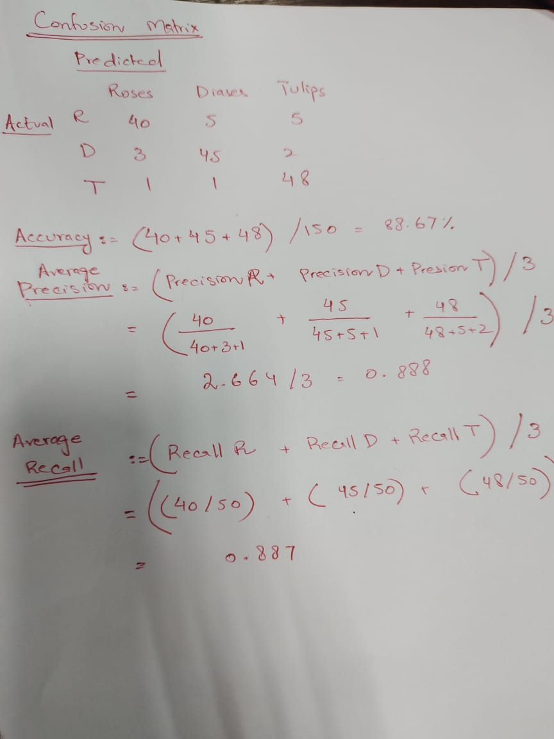

**Question No 5 [Clustering] [4 + 4 + 2 Points]**

For the following points use two iterations of K-means clustering to partition the given points in 2 clusters.

**Points: A1 = (1, 10), A2 = (2, 7), A3 = (8, 5), A4 = (4, 8), A5 = (8, 6), A6 = (7, 5), A7 = (2, 3), A8 = (5, 10)**

Assume that the following points are the Initial centres: C1= (2, 10), C2= (4, 8)

1. Make a table as follows and fill it with the correct values.

|  |  |  |  |
| --- | --- | --- | --- |
| Points | Distance from C1 | Distance from C2 | Cluster |
| A1 | 1 | 3.605551275 | C1 |
| A2 | 3 | 2.236067977 | C2 |
| A3 | 7.810249676 | 5 | C2 |
| A4 | 2.828427125 | 0 | C2 |
| A5 | 7.211102551 | 4.472135955 | C2 |
| A6 | 7.071067812 | 4.242640687 | C2 |
| A7 | 7 | 5.385164807 | C2 |
| A8 | 3 | 2.236067977 | C2 |

Updated C1:(1,10)

C2:(5.142857, 6.2857)

Iteration 2:

|  |  |  |  |
| --- | --- | --- | --- |
| Points | Distance from C1 | Distance from C2 | Cluster |
| A1 | 0 | 5.564097826 | C1 |
| A2 | 3.16227766 | 3.223003973 | C1 |
| A3 | 8.602325267 | 3.133101756 | C2 |
| A4 | 3.605551275 | 2.060315173 | C2 |
| A5 | 8.062257748 | 2.871393148 | C2 |
| A6 | 7.810249676 | 2.258769712 | C2 |
| A7 | 7.071067812 | 4.546808398 | C2 |
| A8 | 4 | 3.717032232 | C2 |

Updated C1:(1.5,8.5)

C2:(5.667,6.1667)

1. Determine the new clusters using the table computed in part I
2. Calculate the updated means for the the new clusters.

**Question No 6 [A* Search] [5 + 3 + 2 Points]**

Consider the state space graph shown below. A is the start state and G is the goal state. The transition costs are next to the edges, and the heuristic estimates are given inside the node. Each edge can be traversed in both directions

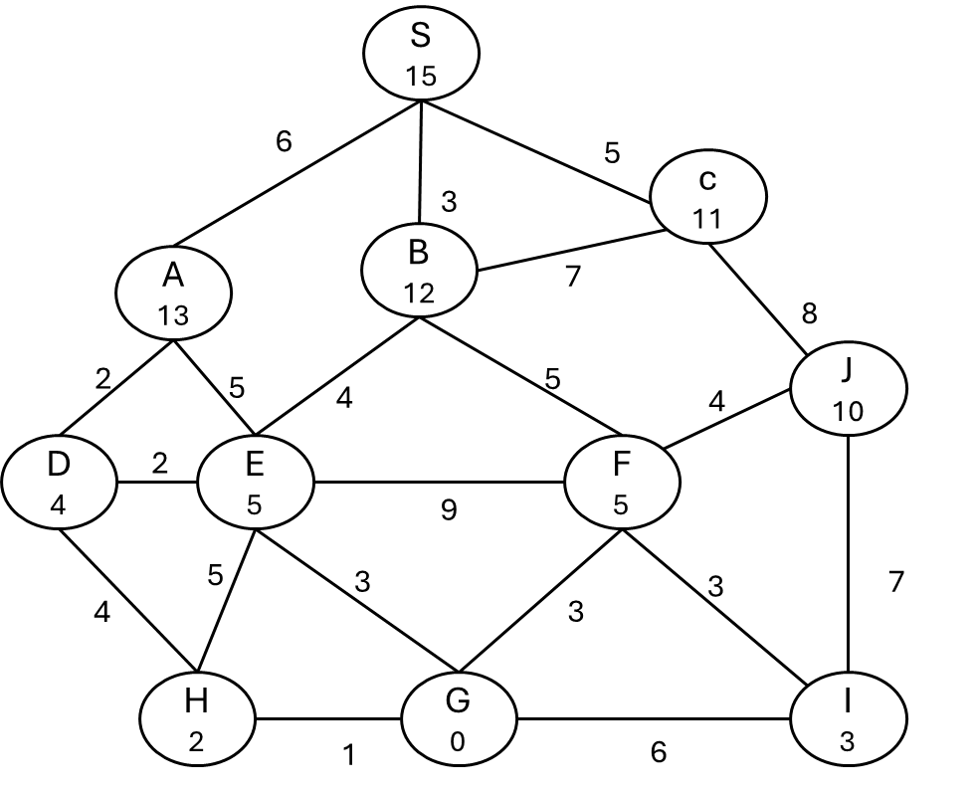S

Consider A* graph search on the graph above. Assume that ties are broken alphabetically (So a partial plan S->X->A would be expanded before S->X->B in case of a tie.

1. What is the order of states expanded and the path found by A* graph search algorithm when used on this problem?
2. Specify the nodes in the fringe/frontier/Queue when the goal is found.
3. Is the heuristic function admissible? Justify your answer.

**Solution: A is the start state and G is the goal state.**

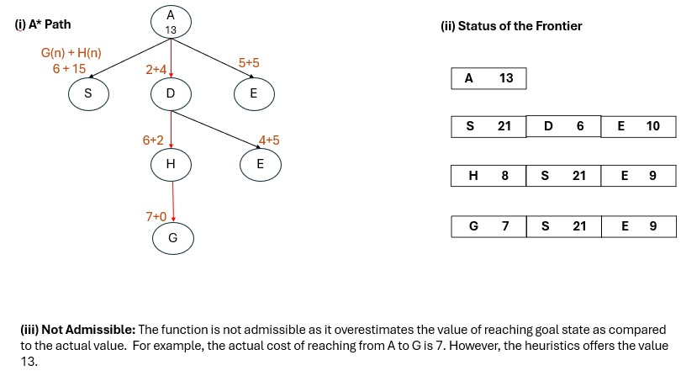

**Solution 2: S is the start state and G is the goal state.**

